Testing Report | Pieces/Rook | 12/10/20  
Tester: Syed Raza  
GitHub Link:   
<https://github.com/J-Rind/Testing/tree/razaTesting/razaBoardTest>  
<https://github.com/J-Rind/Testing/tree/razaTesting/razaKingQueenTest>

**King:**

1. King can move into invalid positions. EX, from start, can move into negative spaces. Needs error checking.

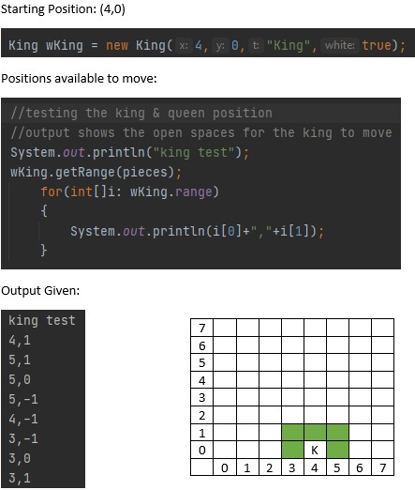

**Queen:**

1. Queen can move only move into valid positions; error checking is in place. ✓

